**Leaving Certificate**

**Computer Science Project 2025**

**Exam Number:**

**1.Meeting the Brief**

Video

The video should be used to demonstrate how your artefact meets the basic and/or advanced requirements of the brief. You should deal with each requirement you attempted in the video and demonstrate how you have achieved it.

This will include the Python and Information System. Focus on showing the requirements, then other features if you have time. This may be the only way the examiner will view your artefact.  
Remember in the first 10-30 seconds to explain what your project is about.

How I met the Basic Requirements

A brief written description with images demonstrating how your artefact meets each of the requirements.

1. Collect and prepare the data

a. Select the dataset you will use.

b. Use Python to extract, clean and store the data that you will need for your project into a suitable format. You will need to provide clear evidence of how you extracted, cleaned and stored this data set.

2. Data analytics and visualisation

a. Use Python to carry out analytics on your data and to create at least two different basic visualisations (e.g., bar chart, line graph, pie chart) with each representing different key aspects of the dataset.

b. Ensure that each visualisation is clearly labelled with titles, axis labels, and legends where appropriate.

c. You should use Python data structure(s) such as lists, tuples or dictionaries to manage the data you will be analysing.

3. Create a basic interactive information system interface

a. Develop a web-based interface to provide the public with information about your chosen dataset.

b. Display the data visualisations you have created in the information system.

How I met the Advanced Requirements

A brief written description with images demonstrating how your artefact meets each of the requirements.

1. Ensure that users can interact with the data visualisations on the information system

(e.g., hover to see details, click to filter data, change ranges, etc.).

2. Create a form or poll relating to your chosen dataset on your information system that collects and stores data from the users.

a. The data collected should contain at least three different data types.

b. The data should be validated and stored in a database or file.

c. Some aspect of the collected data from all users should be summarised and displayed through the information system.

3. Create a separate area on your information system that makes recommendations or helps inform decisions based on your analysis of your chosen dataset.

**2.Investigation**

Research into the Context of the Brief

1 or 2 lines on how you interpret the brief and thoughts on it. What does data mean to you and how it is used to help in the world?

Possible Solutions

What ideas you have in context to what the brief asks. I would suggest 2-3 ideas. Links to existing solutions. This needs to be **existing interactive systems** that have inspired you **and**  **the area you have chosen.** A mind map would be a good way to show possible solutions.

Provide Insights into what you want to find from the data

What is the data you would like to find information about or enquiries that you are interested in investigating.

Possible Research questions for insight into the data.

Environmental Science:

How do urbanization and industrial activities impact air quality in metropolitan areas?

Healthcare:

Is there a link between dietary habits and the incidence of chronic diseases?

Economics:

How do changes in minimum wage affect employment rates in different industries?

Education:

Does the use of technology in classrooms improve student performance?

Social Sciences:

How does social media usage affect mental health among teenagers?

Technology:

How does the adoption of artificial intelligence impact job markets in various sectors?

Public Policy:

What is the effect of gun control laws on crime rates?

Initial thoughts on your own project

Your chosen project and why you have chosen it over other ones you have looked at above. How does your chosen area align with the brief requirements?

**3.Plan and Design**

Clear description of my project

A clear detailed description of the design of your project **and** how it will meet the requirements set out in the brief.  
A GANTT Chart here would be good to explain what you plan to do week by week.

How it meets the requirements of the brief and end users

How you will achieve each of the requirements from the brief. This may overlap with the section before. But it is important to portray how you will achieve these.

Description of the Technologies Used

Python

We are using several Python modules for this project. Pandas is used to read CSV files and perform data analytics. It is essential for data manipulation and analysis due to its powerful data structures like DataFrames. Matplotlib is used for creating charts and graphs, which are necessary for visualizing data insights. Additionally, we use other modules such as NumPy for numerical operations, Seaborn for statistical data visualization, and Scikit-learn for implementing machine learning algorithms. Each of these modules plays a crucial role in handling, analyzing, and visualizing data effectively in the project.

Interactive System

For the interactive system, we are using web development technologies such as HTML, CSS, and JavaScript. HTML is used to structure the content of the web pages, while CSS is used to style and layout the pages to ensure a good user interface design. JavaScript is used to add interactivity to the web pages, allowing users to interact with the data visualizations and other elements on the page. Additionally, we are libraries such as ChartJS for creating dynamic and interactive data visualizations. These technologies work together to create an engaging and user-friendly interactive system that allows users to explore and analyze the data effectively.  
Flowchart

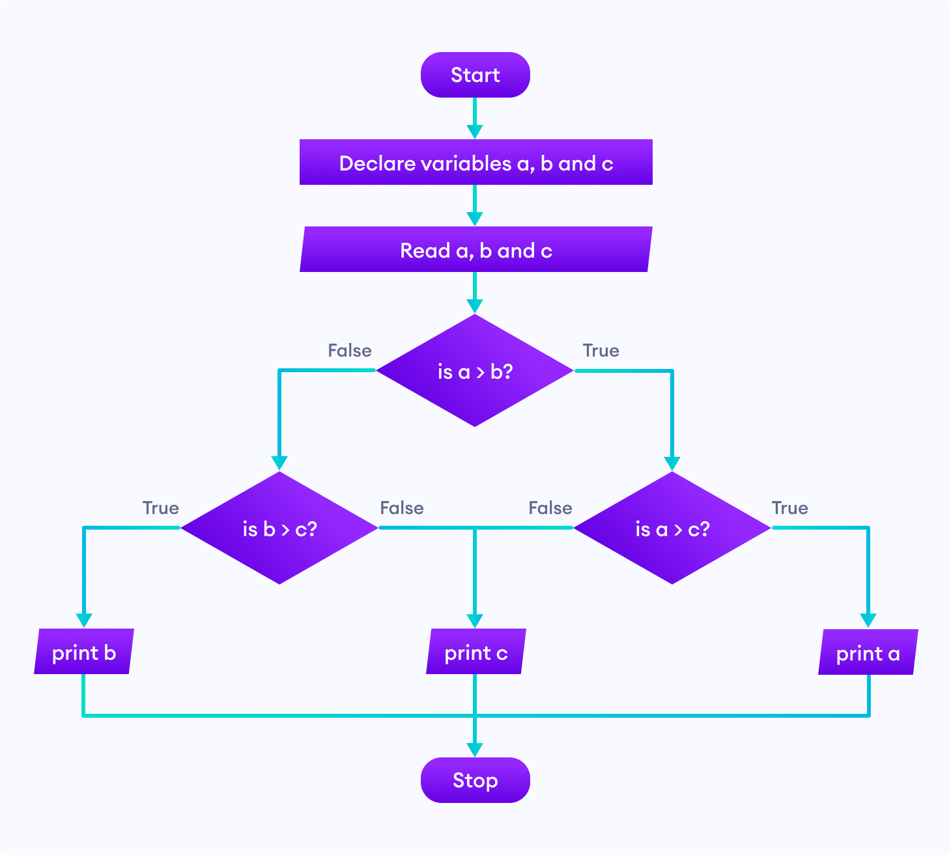

**4.Create**

Progress Log

The progress log which gives an overview of the development process. It

is suggested that this progress log is updated weekly or fortnightly.

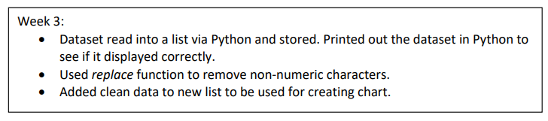

Test Table

A test table is a structured format used to organize and document test cases for a software application. It typically includes columns for test case ID, description, preconditions, test steps, expected results, actual results, and status. This helps ensure that all aspects of the application are tested systematically and thoroughly.

### Test Table for Data Analytics with Pandas

| **Test Case ID** | **Description** | **Preconditions** | **Test Steps** | **Expected Results** | **Actual Results** | **Status** |
| --- | --- | --- | --- | --- | --- | --- |
| DA001 | Verify data loading from CSV | CSV file exists | 1. Use pd.read_csv() to load the file  2. Check DataFrame shape | DataFrame is loaded with correct shape and data |  | Pass/Fail |
| DA002 | Verify data cleaning | DataFrame is loaded | 1. Remove null values using dropna()  2. Check for null values | DataFrame has no null values |  | Pass/Fail |
| DA003 | Verify data aggregation | DataFrame is loaded | 1. Group data using groupby()  2. Aggregate using sum() | Data is correctly aggregated |  | Pass/Fail |
| DA004 | Verify data visualization | DataFrame is loaded | 1. Use matplotlib to create a bar chart  2. Display the chart | Bar chart is displayed with correct data |  | Pass/Fail |

### Test Table for Interactive System with JavaScript

| **Test Case ID** | **Description** | **Preconditions** | **Test Steps** | **Expected Results** | **Actual Results** | **Status** |
| --- | --- | --- | --- | --- | --- | --- |
| JS001 | Verify page load | Web server is running | 1. Open the web page in a browser | Page loads successfully |  | Pass/Fail |
| JS002 | Verify data fetching from API | API is available | 1. Use fetch() to get data from API  2. Check response status | Data is fetched successfully with status 200 |  | Pass/Fail |
| JS003 | Verify data rendering in table | Data is fetched | 1. Render data in an HTML table  2. Check table content | Data is correctly displayed in the table |  | Pass/Fail |
| JS004 | Verify interactive chart | Data is fetched | 1. Use ChartJS to create a chart  2. Add interactivity (e.g., tooltips) | Chart is displayed with correct data and interactivity |  | Pass/Fail |

This table helps testers keep track of what has been tested, what needs to be tested, and the results of those tests.

Other Testing

1. Unit Testing

Unit testing involves testing individual components or functions of a software application to ensure they work as expected.

2. Integration Testing

Integration testing involves testing the interaction between different components or systems to ensure they work together correctly.

3. System Testing

System testing involves testing the complete and integrated software application to ensure it meets the specified requirements.

4. Acceptance Testing

Acceptance testing involves testing the software application to ensure it meets the acceptance criteria and is ready for delivery.

Problems Encountered

State a one major problem encountered, explain what it was - use screenshots and how did you rectify it.

Pseudocode for Data Analytics Algorithms

1. Import necessary libraries

a. Import pandas as pd

b. Import matplotlib.pyplot as plt (for visualization)

2. Load the dataset

a. Read the CSV file into a DataFrame using pd.read_csv('file_path.csv')

3. Explore the dataset

a. Display the first few rows of the DataFrame using df.head()

b. Display summary statistics using df.describe()

c. Check for missing values using df.isnull().sum()

4. Clean the dataset

a. Handle missing values

i. Drop rows with missing values using df.dropna()

ii. Fill missing values with a specific value using df.fillna(value)

b. Remove duplicate rows using df.drop_duplicates()

c. Convert data types if necessary using df.astype()

5. Analyze the dataset

a. Calculate the mean of a specific column

i. Initialize a variable sum to 0

ii. Initialize a variable count to 0

iii. For each value in the column:

1. Add the value to sum

2. Increment count by 1

iv. Calculate the mean by dividing sum by count

b. Group data by a specific column using df.groupby('column_name')

c. Calculate summary statistics (mean, sum, etc.) using groupby object

d. Filter data based on conditions using df[df['column_name'] > value]

6. Visualize the data

a. Create a bar chart using df.plot(kind='bar')

b. Create a line chart using df.plot(kind='line')

c. Create a histogram using df.plot(kind='hist')

d. Create a scatter plot using df.plot(kind='scatter', x='column1', y='column2')

7. Save the results

a. Save the cleaned DataFrame to a new CSV file using df.to_csv('cleaned_file.csv', index=False)

b. Save visualizations as image files using plt.savefig('plot.png')

8. Document the findings

a. Write a summary of the analysis and findings

b. Include visualizations and key statistics in the documentation

Code Explained

This code outlines the steps for performing data analytics with Pandas. It includes importing necessary libraries, loading and exploring the dataset, cleaning the data, performing analysis (such as calculating the mean and grouping data), visualizing the data using various chart types, saving the results, and documenting the findings. Each step ensures the data is processed, analyzed, and presented effectively.

**5.Evaluation**

Evaluation of Requirements from Brief

You should evaluate the final artefact in relation to the requirements set out in the brief.

* Did you achieve the brief requirements?
* How did the project go?

How I met the brief requirements

You should consider how the project has met the needs of the brief requirements.

If you have failed to hit a requirement please mention it here.

Future Improvements

Suggest how you would further improve/iterate this project with justification. If you had more time or could change something, what would you implement in your game? State something for the marks.

**6.References and Word Count**

You must reference any information used in your report or in the creation of your artefact. You will probably need 10 - 20 links that you used placed in here.

You must reference and acknowledge all research sources used such as: publications including books, professional journals and government reports; online sources and other types of media; source code; and material from specialist organisations and relevant individuals. To include such material without properly referencing the source will be considered plagiarism. In addition, the copying from, or reproduction of, material from such sources may also be considered plagiarism.

| Section | Word Count |
| --- | --- |
| 1. Meeting the Brief |  |
| 2. Investigation |  |
| 3. Plan and Design |  |
| 4. Create |  |
| 5. Evaluation |  |
| **Total:** |  |